Software Design Document
Smart Soil Irrigation System



Submitted by
Rabia Rafiq (F22BINFT1M01078)

Submitted to
Sir Abdul Karim Nawaz

Department of Information Technology
Faculty of Computing
The Islamia University of Bahawalpur

Summary

The Smart Soil Irrigation System is an automated solution designed to provide the right amount of water to crops and plants at the right time, improving irrigation efficiency and reducing water wastage. The system consists of a soil moisture sensor, an Arduino-based microcontroller, a water pump, and optionally a Wi-Fi module for remote monitoring. The soil moisture sensor continuously measures the moisture level in the soil and sends this information to the microcontroller, which acts as the brain of the system. When the soil becomes dry, the microcontroller automatically activates the water pump to irrigate the crops, and once the desired moisture level is reached, it turns the pump off. The system is powered by a battery and can be upgraded to run on solar panels for energy efficiency, making it suitable for both small gardens and large farming areas. The programming for the Arduino microcontroller is done in C/C++, and the optional Wi-Fi module allows farmers to monitor soil moisture levels and irrigation status remotely. Overall, the Smart Soil Irrigation System aims to optimize water usage, increase crop yield, simplify the farmer’s work, and provide a reliable, energy-efficient, and scalable irrigation solution.

Table of Contents
1. Application Architecture 3
2. Data Model Schema 7
3. User Interface 10

- Application Architecture
1.1 Overview
The Smart Soil Irrigation System follows a layered embedded system architecture combined with IoT-based remote monitoring. The system is designed to automatically monitor soil moisture levels and control irrigation using a microcontroller. It ensures efficient water usage, reduces human effort, and supports scalability for wide agricultural areas using solar power.
The architecture consists of four main layers:
1. Sensing Layer
2. Control & Processing Layer
3. Actuation Layer
4. Communication & Power Layer
Architecture Layers Description
1. Sensing Layer:
This layer is responsible for collecting real-time data from the environment.
Soil Moisture Sensor
Measures the moisture content of the soil.
Sends analog/digital signals to the microcontroller.
Continuously monitors soil condition.
Function:
Detect dry or wet soil conditions.
Provide accurate moisture data for decision-making.
2. Control & Processing Layer:
This layer acts as the brain of the system.
Microcontroller (Arduino)
Receives data from the soil moisture sensor.
Processes sensor values based on predefined threshold levels.
Decides whether irrigation is required.
Software Details:
Programming Language: *C / C++*
Implements control logic for pump ON/OFF.
Handles communication with Wi-Fi module.
Function:
Analyze sensor data.
Execute automatic decision-making.
Control water pump operations.
3. Actuation Layer:
This layer performs physical actions based on decisions made by the microcontroller.
Water Pump
Activated when soil moisture falls below the threshold.
Deactivated once the desired moisture level is reached.
Function:
Deliver water to crops automatically.
Prevent over-irrigation and water wastage.
4. Communication & Power Layer:
This layer supports remote monitoring and power management.
Communication Component:
Wi-Fi Module (Optional)
Sends soil moisture data and pump status to the user.
Allows remote monitoring via mobile or web application.
Power Component:
Battery for basic operation.
Solar Panel System for wide-area deployment.
Converts solar energy into electrical power.
Ensures energy efficiency and sustainability.
Function:
Enable wireless data transmission.
Provide continuous and eco-friendly power supply.
1.2 System Architecture Flow (Textual Representation)
Soil Moisture Sensor → Arduino Microcontroller → Decision Logic → Water Pump
Arduino → Wi-Fi Module → User Monitoring Interface
Power Supply → Battery / Solar Panel → Entire System
Architectural Benefits:
Automatic irrigation with minimal human intervention
Reduced water wastage
Improved crop yield
Scalable for small and large agricultural areas
Energy-efficient using solar power
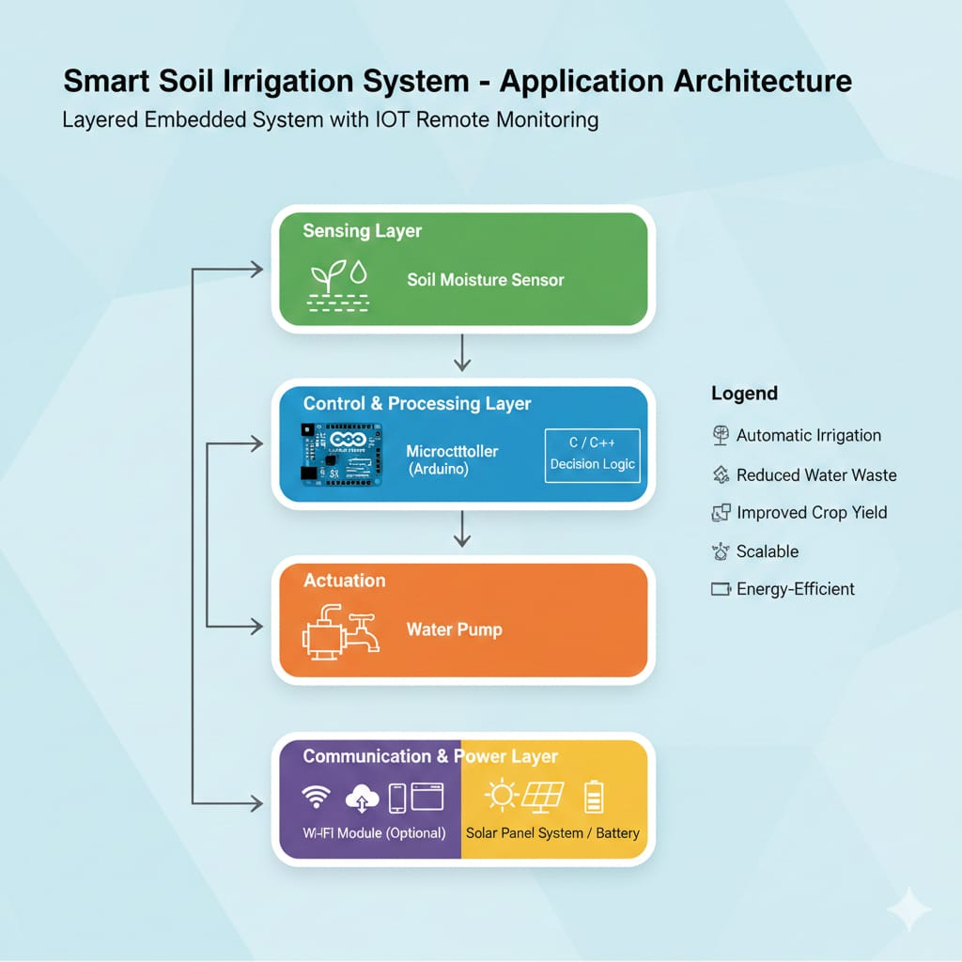

1.2 Architectural Pattern – MVC
The Smart Soil Irrigation System follows the MVC architectural pattern to separate data handling, control logic, and user interaction. This separation improves maintainability, scalability, and system clarity.
- Model
The Model represents the core data and business logic of the system. It manages sensor readings, system states, and threshold values
- View
The View represents the user interface where system information is displayed
- Controller
The Controller acts as the brain of the system. It receives data from the Model, applies decision logic, and controls hardware components

1.Embedded Control Level (Core Automation Logic)
This level manages the real-time irrigation process directly on the microcontroller (Arduino). It operates independently of the internet and ensures uninterrupted automation.
MVC Component | System Component | Description
Model | Sensor Readings & Thresholds | Stores real-time soil moisture values, predefined moisture threshold, and the current pump state (ON/OFF).
View | System State Indicators (LEDs) | Local physical indicators such as LEDs showing system status (e.g., green = sufficient moisture, red = dry soil).
Controller | Microcontroller Code (C/C++) | Decision-making logic that reads sensor data, compares it with thresholds, and controls the water pump accordingly.

2.IoT Remote Monitoring Level (User Interface)
This level enables remote monitoring and configuration through a mobile or web application using a Wi-Fi module.
MVC Component | System Component | Description
Model | Cloud Database / Server | Stores historical moisture data, pump status, and user-defined threshold values.
View | Mobile / Web Application | User interface displaying moisture graphs, pump status, and configuration options.
Controller | Backend API / Server Logic | Processes user requests, updates the database, and sends control commands back to the microcontroller via Wi-Fi.

1.3 System Flow Description
The Smart Soil Irrigation System begins operation when power is supplied to the system through a battery, which can be supported by solar panels for improved energy efficiency in large-area applications. A soil moisture sensor continuously monitors the moisture level of the soil and sends real-time data to the microcontroller. The microcontroller, such as an Arduino, processes the received sensor data and compares it with a predefined moisture threshold programmed using C/C++. If the soil moisture level falls below the threshold, indicating dry soil, the microcontroller automatically activates the water pump to start irrigation. Water is supplied to the crops until the soil moisture sensor detects that the desired moisture level has been reached. Once adequate moisture is achieved, the microcontroller automatically turns off the water pump to prevent over-irrigation and water wastage. This monitoring and control process runs continuously to ensure efficient irrigation. Additionally, a Wi-Fi module can be integrated into the system to allow users to remotely monitor soil moisture levels and irrigation status, making the system more convenient and user-friendly for farmers.
The Smart Soil Irrigation System operates by continuously monitoring soil moisture levels and automatically controlling irrigation based on predefined conditions.
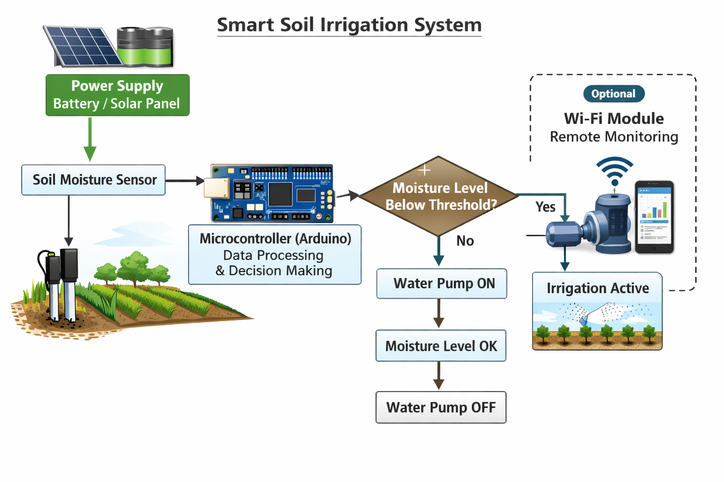

- Data Model Schema
2.1 Data Model
The data model of the Smart Soil Irrigation System defines the structure of data used for monitoring soil conditions, controlling irrigation, and enabling remote access. The system mainly handles sensor data, control data, and system status data.
The Soil Moisture Data represents the real-time moisture level of the soil. This data is collected continuously by the soil moisture sensor and sent to the microcontroller for processing. Each moisture reading includes the current moisture value and is compared against a predefined threshold value stored in the system.
The Threshold Data defines the minimum acceptable soil moisture level. This value is predefined in the microcontroller program and is used as a reference for decision-making. If the sensor value falls below this threshold, irrigation is triggered.
The Pump Control Data represents the operational state of the water pump. It stores whether the pump is in an ON or OFF state. This data is updated by the microcontroller based on the comparison between soil moisture data and the threshold value.
The Power Status Data represents the current power source and availability. It includes information about whether the system is operating on battery power or solar power and ensures the system has sufficient energy to function properly.
The Wireless Monitoring Data (optional) represents data transmitted through the Wi-Fi module. This includes soil moisture readings, pump status, and system alerts that allow the user to remotely monitor the irrigation system.
All these data entities interact through the microcontroller, which acts as the central processing unit. The data model ensures smooth communication between hardware components and supports automatic decision-making to optimize water usage.

Simple Data Model Table (for clarity in SDD)
Data Entity | Description
Soil Moisture Value | Current moisture level detected by sensor
Moisture Threshold | Predefined value for irrigation decision
Pump Status | ON or OFF state of water pump
Power Status | Battery / Solar power availability
Wireless Data | Remote monitoring data via Wi-Fi

2.2 ER Diagram – Data Model
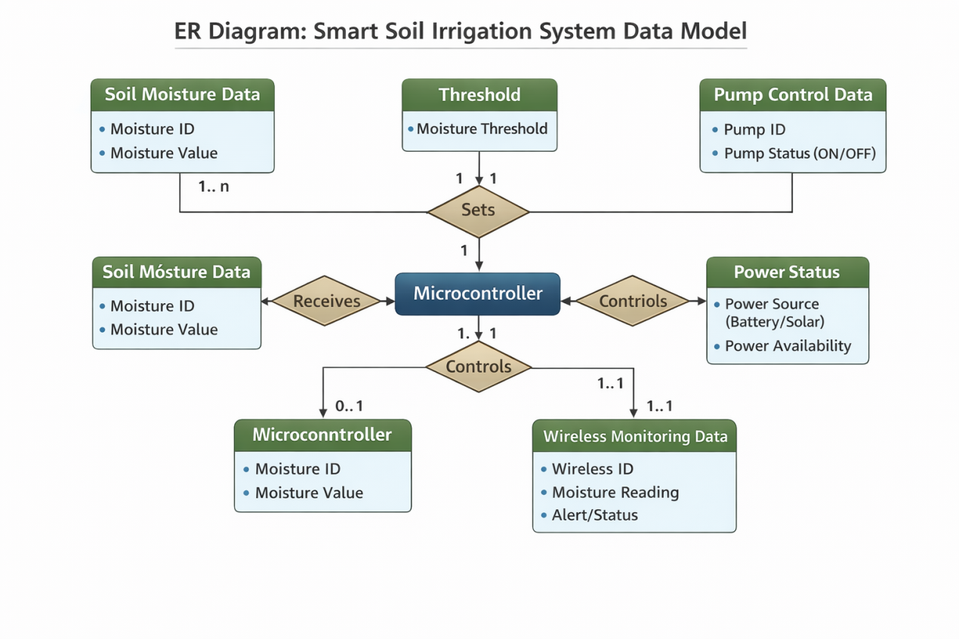

3.User Interface
The user interface allows the farmer or user to monitor and interact with the irrigation system. The UI should be simple, intuitive, and easy to use, with the following features:
3.1 Local Interface
If there is no Wi-Fi module, the UI can be a small LCD screen connected to Arduino showing:
- Current soil moisture level (%)
- Pump status (ON/OFF)
- Battery level or power source status.
3.2 Remote Interface (with Wi-Fi module)
- A mobile app or web interface will allow the user to:
- View real-time soil moisture levels.
- Check pump status.
- Set or adjust moisture threshold levels.
- Receive notifications if soil moisture is too low or if the system encounters an error.
3.3 UI Design Considerations
- Simple layout for easy understanding.
- Clear color-coded indicators for water status (e.g., green for sufficient moisture, red for dry soil).
- Mobile-friendly and responsive design for remote monitoring.
- Minimal user input required, as the system is mostly automatic.

4.System constraints
The Smart Soil Irrigation System operates under certain technical and environmental limitations that affect its performance.
The system depends on electrical power supplied by a battery and solar panel. If the battery is low and sunlight is not available, the system may temporarily stop functioning. The Wi-Fi module also depends on a stable internet connection for remote monitoring. If network coverage is weak or unavailable, data transmission to the user will not be possible.
The soil moisture sensor may also be affected by environmental conditions such as soil type, temperature, or corrosion, which can influence measurement accuracy. Dust, humidity, and exposure to weather may impact electronic components if not properly protected.

5.Assumptions and Dependencies
The Smart Soil Irrigation System is designed based on the following assumptions:
The soil moisture sensor is correctly placed in the soil near the plant roots.
The water pump is properly connected to a water source.
The Arduino microcontroller and Wi-Fi module are configured correctly.
The battery and solar panel are functioning properly.
The system depends on the soil moisture sensor to provide accurate readings. It also depends on the relay and water pump to supply water when required. The Wi-Fi network is required for remote monitoring, and sufficient power is required for continuous operation.
If any of these assumptions or dependencies are not met, the system may not operate as expected.

6.Error Handling and Fault Management
The Smart Soil Irrigation System is designed to handle possible failures to maintain reliable operation.
If the soil moisture sensor fails or provides invalid data, the Arduino ignores incorrect readings and prevents the pump from turning on to avoid over-watering. The system continues checking until valid sensor data is received.
If the Wi-Fi connection is lost, remote monitoring will stop, but the automatic irrigation process continues locally. Once the connection is restored, data transmission resumes.
If power drops due to a low battery or lack of solar energy, the system shuts down safely to prevent hardware damage. When power becomes available again, the system restarts and continues normal operation.
This error-handling approach ensures that the system remains safe, reliable, and efficient.

7.Security Design
Security is important in an IoT-based system because data and control commands are transmitted wirelessly. The Smart Soil Irrigation System uses the Wi-Fi module to send soil moisture readings and pump status to the user. This data is sent over a secured network so that unauthorized users cannot easily access it.
Only the authorized farmer is allowed to monitor the system and receive updates. The system does not accept commands from unknown devices, which prevents misuse or unauthorized control of the water pump. The Arduino also validates all incoming data from the Wi-Fi module before performing any action.
This security design ensures that irrigation data remains private and the system cannot be controlled by unauthorized users.

8.Deployment Architecture & Future Scalability
The Smart Soil Irrigation System is deployed directly in the agricultural field. The soil moisture sensor is installed in the soil near the crop roots to measure accurate moisture levels. The Arduino microcontroller, Wi-Fi module, and relay are placed inside a protective enclosure to prevent damage from dust, rain, and sunlight.
The water pump is installed near the water source and connected to irrigation pipes. It is controlled by the Arduino through the relay. The battery and solar panel are placed close to the control unit. The solar panel is positioned in an open area to receive maximum sunlight and charge the battery.
This deployment setup allows the system to operate efficiently in outdoor farming environments.
FUTURE SCALABILITY:
The Smart Soil Irrigation System is designed so that it can be expanded for larger agricultural areas. Additional soil moisture sensors can be installed in different parts of the field to monitor moisture in multiple zones.
Multiple water pumps can also be added so that different areas of the farm can be irrigated independently. The system can be upgraded with more powerful microcontrollers and better communication modules to support large farms and advanced monitoring features.
This scalability makes the system suitable for both small gardens and large agricultural fields.

